Laxmi Charitable Trust’s
Sheth L.U.J College of Arts & Sir M.V. College of Science and Commerce
Department of Information Technology (B.Sc.I.T Semester V)
Data Visualization with Power BI and Tableau

TABLEAU DASHBOARD PROJECT

Sales Performance Analysis Dashboard

Student Name | SOM MISHRA
Roll No. | T023
Class / Batch | Bsc.IT
Subject | Tableau
Academic Year | TYIT

Submitted to:

Project Title

Retail Profitability and Customer Behavior Analysis Using Tableau

Objective

To analyze retail sales, profit, and discount impact across regions and product categories using interactive Tableau visualizations.

To calculate and evaluate profitability using the Profit Ratio calculated field, with Region and Category filters for deeper insights.

To segment customers based on Recency, Frequency, and Monetary (RFM) values and identify high-value customers.

To build interactive dashboards that support data-driven decisions on sales strategy, discount planning, and customer retention.

Project Description
This project analyzes a retail dataset of 100 orders from 25 customers across four regions (North, South, East, West) and four product categories (Furniture, Clothing, Electronics, Grocery) using Tableau. The first part builds an interactive sales and profitability dashboard with bar, line, and map visualizations, a Profit Ratio calculated field, and Region and Category filters to study how sales, profit, and discounts vary across regions. The second part applies RFM (Recency, Frequency, Monetary) analysis to segment customers into High-Value, Regular, and At-Risk groups, using scatter plots and a segmentation dashboard to highlight the most valuable customers. Together, the dashboards give clear insights to support decisions on regional sales strategy, discount planning, and customer retention.

Dataset Details

Parameter | Details
Dataset Name | Retail Customer Analytics Dataset (100 records, 12 attributes)
Source | Kaggle
Number of Records | Each record is one order. The 100 orders come from 25 unique customers, and the order dates run from 2 January 2025 to 11 April 2025.
Important Fields | Region, Category, OrderDate, Sales, Profit, Discount, CustomerID, CustomerName, Recency, Frequency, Monetary

Tools & Technologies Used
  - Tableau Desktop
  - CSV Dataset
  - Kaggle Dataset
  - Data Visualization
  - Dashboard Design
  - RFM Analysis
  - Customer Clustering

Tableau Worksheets / Charts

Visualization | Purpose
KPI Cards | Display Total Sales, Total Profit and Profit Ratio
Sales Trend – Line Chart | Analyze sales and profit performance over time (Jan to Apr 2025)
Bar Chart– Sales by Category:  Profit by Region: | Compare sales and profit across Furniture, Clothing, Electronics and Grocery  Compare profitability across North, South, East and West
Map / Bar Chart | Visualize sales and Profit Ratio geographically by region
High-Value Customers Chart | Identify customers with the highest monetary value for the business
Interactive Filters | Filter the dashboards by Region, Category, Customer and Customer Segment

Calculated Fields
The following calculated fields can be used in the Tableau dashboard:

Profit Ratio = SUM([Profit]) / SUM([Sales])

Total Sales = SUM([Sales])

Total Profit = SUM([Profit])

Last Order Date = { FIXED [CustomerName] : MAX([OrderDate]) }

Reference Date = { FIXED : MAX([OrderDate]) }

Recency (Days) = DATEDIFF('day', [Last Order Date], [Reference Date])

Frequency (Orders) = { FIXED [CustomerName] : COUNTD([OrderID]) }

Monetary Value = { FIXED [CustomerName] : SUM([Sales]) }

High Value Customer =
IF [Monetary Value] >= { FIXED : AVG([Monetary Value]) }
THEN "High Value"
ELSE "Other"
END

Customer segment field (used in the segmentation dashboard):

Customer Segment =
IF {FIXED [CustomerID] : AVG([Monetary])} >= 13000 AND {FIXED [CustomerID] : AVG([Recency])} <= 180 THEN "High-Value"
ELSEIF {FIXED [CustomerID] : AVG([Recency])} >= 200 THEN "At-Risk"
ELSE "Regular" END

Dashboard Screenshot
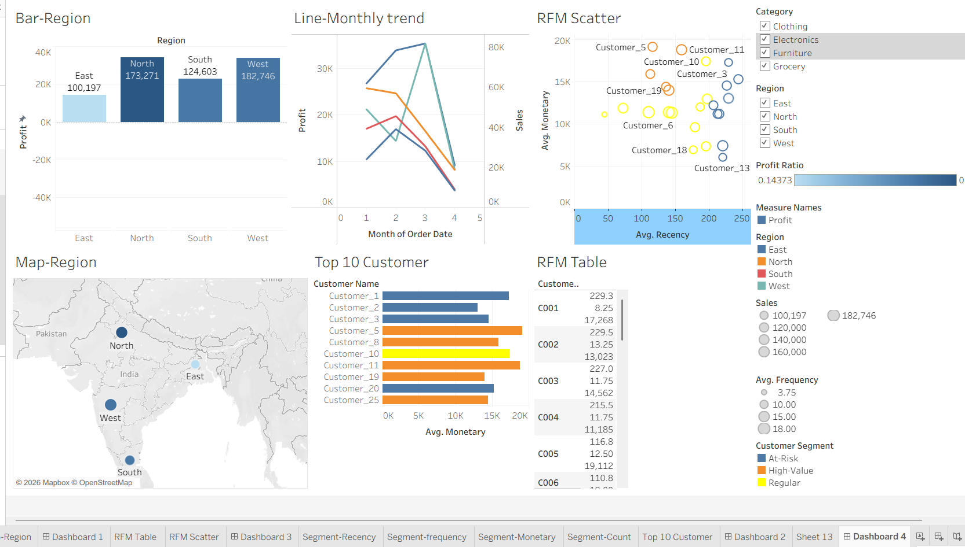

Key Insights

- Overall performance: Total sales are about ₹5.81 lakh and total profit about ₹1.05 lakh, giving a Profit Ratio of 18.1%.
- Regional performance: North is the strongest region (highest profit ~₹34,143 and best Profit Ratio of 19.7%), while East is the weakest (lowest sales and a Profit Ratio of only 14.4%).
- Category performance: Electronics is the most profitable category (Profit Ratio 21.9%). Clothing has the highest sales but the lowest margin (15.8%).
- Discount impact: Orders with up to 20% discount keep a Profit Ratio of about 20 to 21%, but at 20 to 30% discount it drops to 12.3%. Heavy discounting hurts profit.
- Sales trend: Sales and profit grow steadily from January to March. April looks low only because the data ends on 11 April.
- Customer segments: The 25 customers split into 5 High-Value, 11 Regular and 9 At-Risk. High-Value customers (C005, C008, C011, C019, C025) spend the most (~₹16,400 on average) and buy more recently.
- Customer concentration and risk: The top 5 customers contribute about 26% of total sales, while At-Risk customers have not purchased for 220+ days. C011 is a top customer by sales but earns very little profit, pointing to heavy discounts.

Video Demonstration
Video Link : https://youtu.be/89UZv-qb2Ls?si=rfz_AdJwQk_JeOW1

GitHub Repository
GitHub Link :https://github.com/som2711/Data-visualization-

